Environmental impacts of Hungarian agriculture and quantity-quality issues of food supply

The farmland bird index is widely used to measure the environmental impact of agriculture. This index has changed negatively over the last decade. The EUROSTAT agri-environmental database recorded a 30-point decrease in the index between 1999 and 2019 (Figure 1).

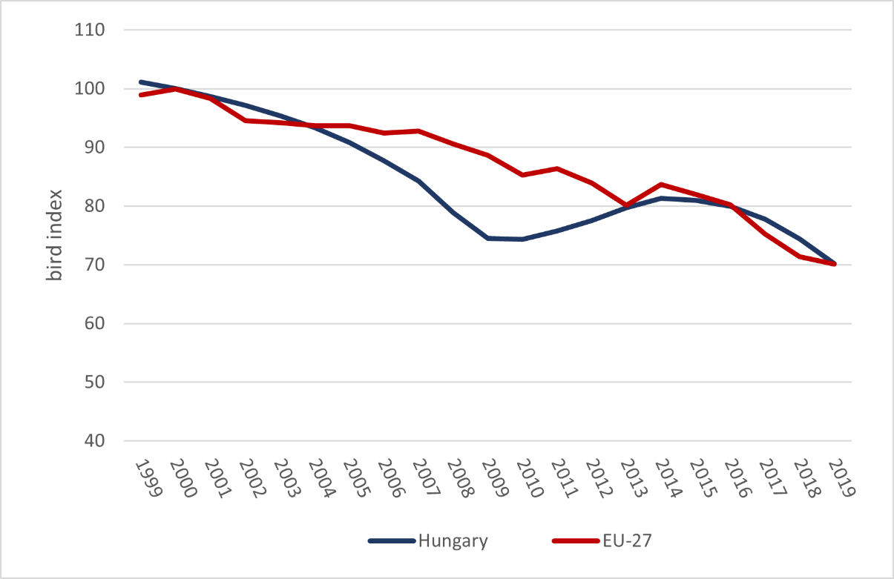
Figure 1: Changes in the common farmland bird index, 1999-2019, (2000=100%)
Source: Eurostat, http://ec.europa.eu/eurostat/web/agri-environmental-indicators

It should be noted, however, that the decline of farmland bird populations is a general European trend – even if not as rapid as in Hungary. This raises serious questions about the effectiveness of the greening of the CAP, agri-environmental measures and NATURA2000 programmes, and the need for their future correction (ECA, 2017).
Some general conclusions can be drawn from all these developments. Different national and European agricultural regulations have multiple (and often unforeseen) environmental impacts and sometimes set off chain reactions. Despite the environmental ambitions, the current agricultural regulatory system has generally negative impacts on the environment. This also indicates that further conflicts of interest between the agricultural sector and the environment are likely in the future.
Among the many functions of agriculture, the production of food is the most important. Food security is both a quantitative and qualitative issue, which has a strong impact on the financing and sustainability of agriculture at European level. Malnutrition is not confined to third world countries; the phenomenon is also present in Europe, albeit on a much smaller scale. Between 2014 and 2019, the proportion of undernourished people decreased on average in the EU and in Hungary, but to a greater extent in the latter case, resulting in a lower Hungarian figure than the EU average today. However, this positive trend cannot be said for the evolution of the proportions of the normal and obese population. While the proportion of people with a normal body mass index has decreased, the proportion of obese people has increased, to a greater extent in Hungary than in the European Union (Figure 2).

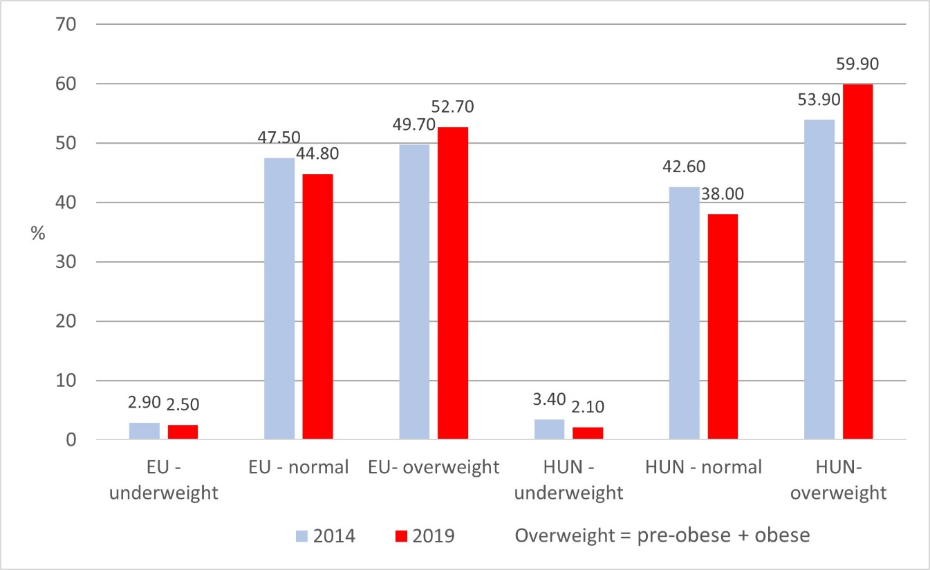
Figure 2: Body Mass Index in Hungary and the EU (2014; 2019)
Source: Eurostat

The negative trend in the body mass index highlights the need for changes in eating habits and problems with the quantity and quality of food. In addition to the material conditions, the quality of food available is also a factor behind over-nutrition. This is also true if we accept that the less well-off in society are turning to poorer quality food. However, quantitative data on the consumption of each food category show that, for example, consumption of meat has increased by around 20% over ten years, while that of fats has increased by around 10% (Figure 3). This suggests that the consumption of more nutritious meats, rather than the more fatty meats that are perceived as unhealthy, has increased more. It should also be borne in mind that organic foods, in addition to being in the higher price range, have a higher nutritional value and can therefore be consumed in smaller quantities to meet the calorie intake requirements, which in aggregate can result in maintaining the cost level of 'conventional' foods.
Nutrition issues can be linked to the performance of agriculture, including organic farming. Several researchers have concluded (Seufert et al., 2012; Paarlberg, 2022) that the expansion of organic farming is hampering the ability to meet the food needs of the population due to poorer yields. If we add to this finding the over-nutrition data, the picture becomes more nuanced. Overproduction or overconsumption is often the problem for European agriculture, which calls into question the criticisms of increasing the area under organic farming.

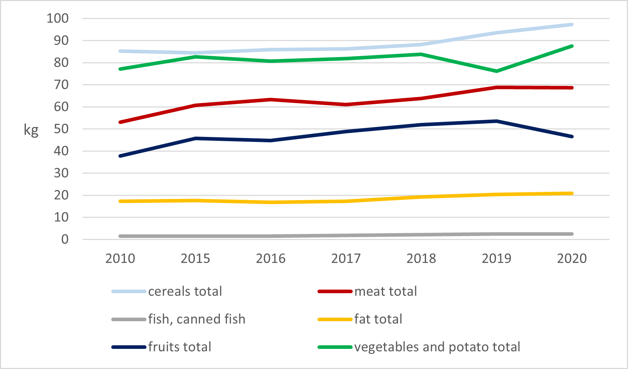
Figure 3: Food consumption in Hungary 2010-2020
Source: Eurostat

The transformation of food consumption patterns in Hungary can be clearly traced in the consumption data for individual food categories (Figure 6). The consumption of fats, and especially meat, has gradually increased over the past decade, indicating a shift away from healthy, quality food. This is also reflected in the decline in fruit consumption and the stagnation in vegetable consumption, with potatoes accounting for the largest share. It is worth noting that total food consumption in Hungary has increased by 16% in the last ten years, from 272 kg to 323 kg (person/year) (Eurostat). The reduction of food waste from 175 kg per capita in 2010 to 93 kg per capita in 2020 is a positive trend and should be an important objective for the future, both from an environmental and a food point of view.
If we start with the overconsumption of food and take into account the distribution of food types, it can be seen that there is room for further expansion of organic farming with lower productivity. The new CAP target to increase the share of organic farming to 25% by 2030, while ambitious, would not be impossible with a shift towards consumption of higher quality, higher nutritional value foods (Leifert, 2022). In terms of agricultural policy objectives, it should be considered to promote the introduction of organic farming and backyard farming to a larger share of the less well-off, which could contribute to a healthy food supply and reduce vulnerability by shifting towards self-sufficiency.
CAPTIVATE project, funded under the Erasmus + program of the European Union, is dedicated to knowledge transfer and vocational training of farmers and agricultural advisors related to the current EU strategic lines, such as the Green Deal, Farm to Fork Strategy and Organic Action Plan. One of the CAPTIVATE’s main objectives is that farmers better understand conditionality, eco-scheme and rural development regulations, they choose and participate in the certain schemes with more responsibility and awareness, carrying out the new CAP measures more effectively.
