Changes in energy and water demand and land use in Hungarian agriculture

Databases from Eurostat and the Hungarian Central Statistical Office (KSH) can be used to track changes in the intensity of Hungarian agriculture, energy and water demand, and land use.
There is a worldwide trend towards more intensive agricultural production, which goes hand in hand with an increase in input use (water, pesticides, fertilisers, etc.), which in turn works against sustainability. Sustainability is also threatened by the increase in energy use, which is also relevant for greenhouse gas emissions. Over the last ten years, there has been a significant change in the cost of energy in agriculture, which is not only reflected in rising prices, but also in the increase in the amount of energy used. In addition, GHG emissions from agriculture in Hungary have increased at a higher rate than the European average over the last decade, with the result that emissions are now above the EU average (Figure 1).
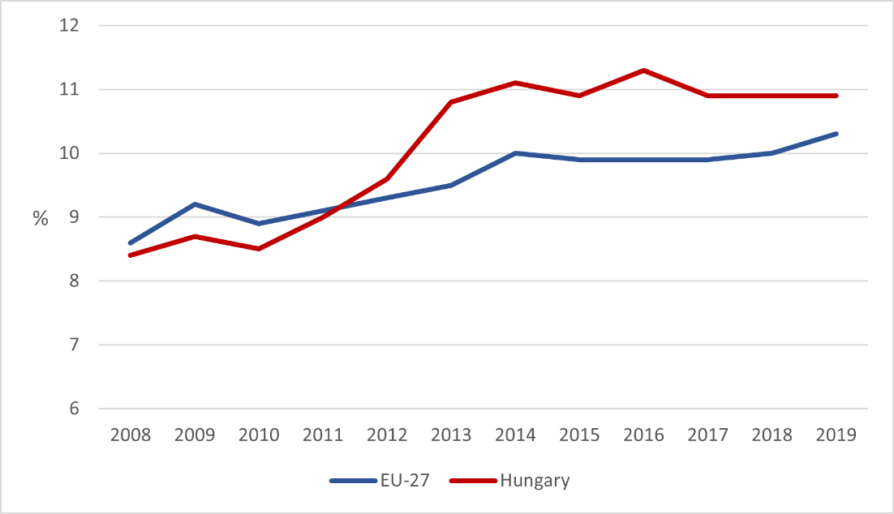
Figure 1: Greenhouse gas emission of agriculture in Hungary and within the EU between 2008 and 2019.
Source: Eurostat, http://ec.europa.eu/eurostat/web/agri-environmental-indicators

Eurostat data show that the positive trend of decreasing energy consumption in the 2010s was reversed, with energy consumption increasing by 32% between 2010 and 2016. Energy costs increased by 37% (from 114713 to 180657 million HUF) between 2011 and 2020.
The economic collapse after the change of regime led to a decline in the use of fertilisers, pesticides and other inputs. However, after 2000, the amount of fertiliser used per hectare doubled (2000: 61 kg/ha; 2021: 133 kg/ha). In addition, the amount of water used for irrigation has also increased over the last 20 years (from 110.7 to 140.56 million m³, depending on the availability or scarcity of rainfall) (ksh.hu). As a consequence, irrigation options will become more and more questionable in the future, so that increasing water use cannot be considered a sustainable trend. Adaptation of agriculture also involves the choice of cultivation practices and crop varieties that can produce satisfactory yields under drier conditions, possibly without irrigation. Organic farming, or alternative forms of farming such as permaculture, can play a prominent role in this process. The evolution of the different inputs is shown in Figure 2.

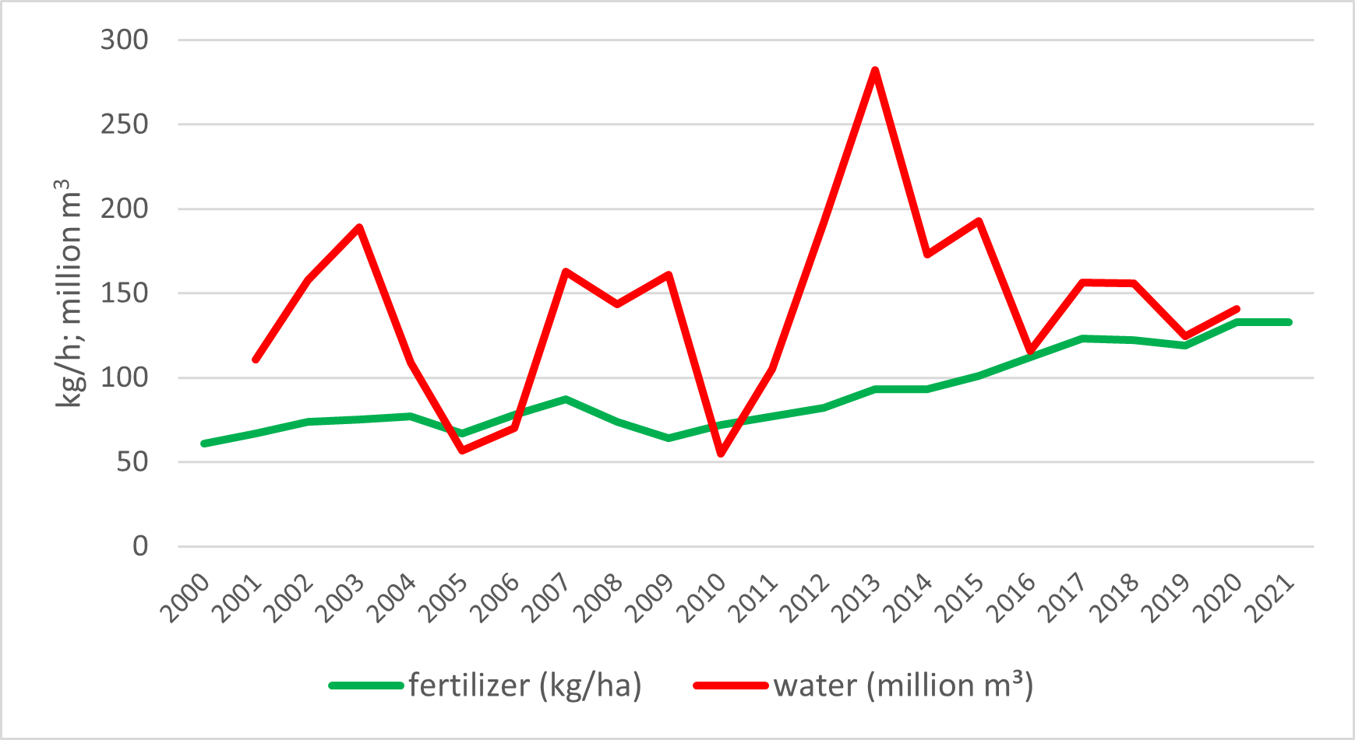
Figure 2: Trends in fertilizer and irrigation water use of agriculture between 2000 and 2021 in Hungary
Source: KSH

In Hungary, the rise of organic farming has taken a particular shape. The appearance of cultivated land under organic farming and agri-environmental measures dates back to the early 2000s. Farmers initially welcomed the agri-environmental programmes and opportunities, but the total area under agri-environmental measures declined somewhat due to the difficulties of the bureaucratic system after EU accession.
In the case of organic farming, in contrast to the EU, there was no significant increase in area until the 2010s, which stagnated at around 2% for a long time. However, thereafter, the proportion of organic farming areas increased at a similar rate as in the EU, with an increase of 3-3.5% between 2012 and 2020 (Figure 3).

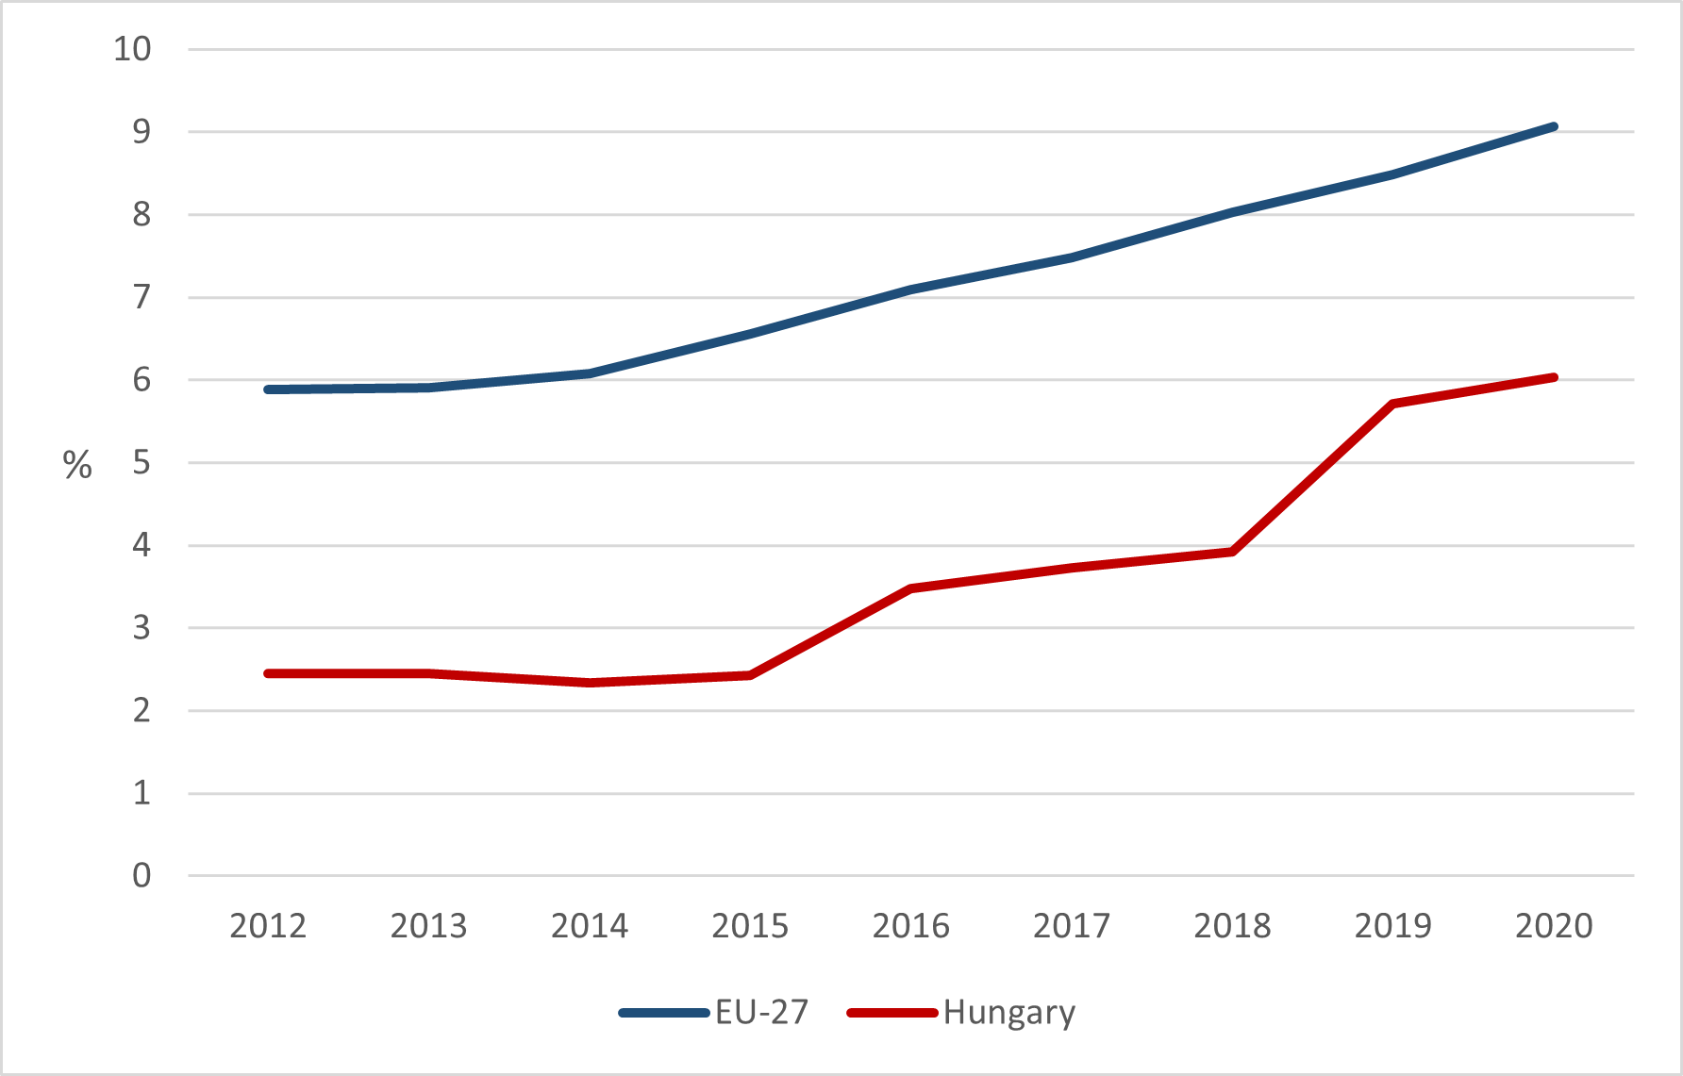
Figure 3: Area under organic farming
Source: EUROSTAT, Agrár-környezetgazdálkodási indikátorok, http://ec.europa.eu/eurostat/web/agri-environmental-indicators

CAPTIVATE project, funded under the Erasmus + program of the European Union, is dedicated to knowledge transfer and vocational training of farmers and agricultural advisors related to the current EU strategic lines, such as the Green Deal, Farm to Fork Strategy and Organic Action Plan. One of the CAPTIVATE’s main objectives is that farmers better understand conditionality, eco-scheme and rural development regulations, they choose and participate in the certain schemes with more responsibility and awareness, carrying out the new CAP measures more effectively.
